**PSY 653 Module 06: Repeated Measures and Mixed Designs in ANOVAs**

Use the following experimental design to complete the tasks below:

*There are 30 subjects who each read three passages from one book and rate their liking of the passage. Passages depict 1 – outdoor activities, 2 – interactions with family and 3 – interpersonal conflict, which is resolved. Half of the books are written by male authors (M) and half are written by female authors (F). Half of the participants were randomly assigned to read books written by male authors, and the other half were randomly assigned to read the books from female authors.*

*The experiment was run as so:*

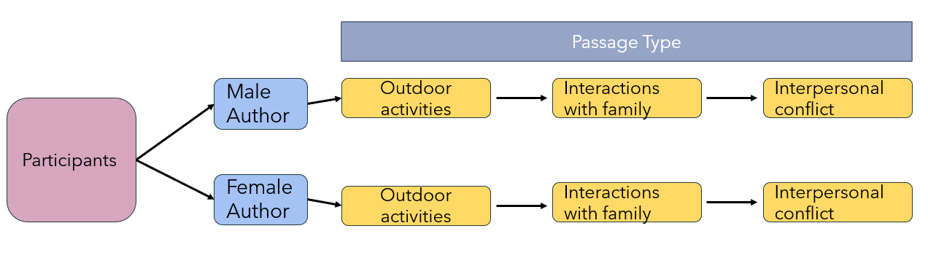

The data contains the following variables:

**Y** = participants’ ratings of how much they liked each passage (the outcome variable)

**Subject** = participant ID number (N = 30)

**Passage** = a 3-level factor variable for the type of passage, coded as either 1 = Outdoor activities, 2 = interactions with family, or 3 = interpersonal conflict.

**Author** = a 2-level factor variable for author self-identified sex, coded as either 0 = Female or 1 = Male

1. Which variable is a within-subject variable? Which is a between-subject variable? How do you know?
2. Download the RMexample.csv datafile from canvas and save it into an R-project folder.
3. Create a new R-notebook and name it “RMANOVA_notebook”
4. Create a first level header: “Load Libraries”
   1. In a new R chunk: Load the psych, ez, and tidyverse packages
5. Create a new R chunk with the first level header: “Import data”
   1. Read in the “RMexample.csv” datafile. Assign it to an object called “RM”
6. Create a first level header: “Factor my predictor variables”
   1. Factor the following variables:
      1. **Subject** (just use as.factor to factor this variable). Name the new variable Subject.f
      2. **Passage** so that 1 = “Outdoor Act”, 2 = “Int w fam”, & 3 = “Interpers conf”. Name this newly created variable Passage.f
      3. **Author** so that 0 = “Female author”, 1 = “Male author”. Name this newly created variable Author.f
7. Create a new first level header: “Reduce the dataset to outcome and factored predictors”
   1. In an R chunk, select the following variables from the dataset: Y, Subject.f, Passage.f & Author.f
8. Create a first level header: “Get dataset descriptives”
   1. In an R-chunk, use any method to get dataset descriptives
9. Create a first level header: “Analyze Repeated measures design with ezANOVA()
   1. Use the ezANOVA function to conduct the appropriate repeated measures ANOVA that evaluates both the within-subject effects and the between-subject effects.
   2. Create a second level header: “Step 1: Check If sphericity was violated”
      1. Was sphericity violated in this model? (Hint: Window 3!)
         1. If sphericity was violated, how should you proceed? Which output window should you look at for your significance test?
   3. Create a second level header: “Step 2: Interpret results”
      1. Interpret the results to the correct test. (Hint: the correct test is determined by whether your sphericity was violated or not)